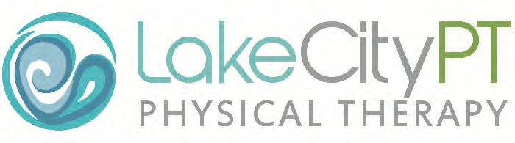

INTRAMUSCULAR STIMULATION DRY NEEDLING
Intramuscular stimulation dry needling (IMS) involves inserting a tiny monofilament needle in a muscle or muscles in order to release shortened bands of muscles and decrease trigger point activity. This can help resolve pain and muscle tension and will promote healing. This is not traditional Chinese Acupuncture, but is instead a medical treatment that relies on a medical diagnosis to be effective. Your physical therapist trained by Dr. Steven Goodman has met requirements for competency and is currently a certified Intramuscular Stimulation (IMS) Practitioner.

IMS is a valuable and effective treatment for musculoskeletal pain. Like any treatment, there are possible complications. While complications are rare in occurrence, they are real and must be considered prior to giving consent for treatment.

Risk: The most serious risk with IMS is accidental puncture of a lung (pneumothorax). If this were to occur, it may require a chest x-ray and no further treatment. The symptoms of shortness of breath may last for several days to weeks. A more severe puncture can require hospitalization and re-inflation of the lung. This is a rare complication, and in skilled hands it should not be a major concern. Other risks include injury to a blood vessel causing a bruise, infection, and/or nerve injury. Bruising is a common occurrence and should not be a concern.

Patient’s Consent: I understand that no guarantee or assurance has been made as to the results of this procedure and that it may not cure my condition. My therapist has also discussed with me the probability of success of this procedure, as well as the probability of serious side effects. Multiple treatment sessions may be required/needed; thus, this consent will cover this treatment as well as consecutive treatments by this facility. I have read and fully understand this consent form and understand that I should not sign this form until all items, including my questions, have been explained or answered to my satisfaction. With my signature, I hereby consent to the performance of this procedure. I also consent to any measures necessary to correct complications which may result.

Procedure: I,______________________________________, authorize ________________________________ to perform Intramuscular Stimulation for my diagnosis of __________________________________________________________________________________________.

Please answer the following questions:

Are you pregnant? Yes No Are you immunocompromised? Yes No Are you taking blood thinners? Yes No

DO NOT SIGN UNLESS YOU HAVE READ AND UNDERSTAND THIS FORM.

You have the right to withdraw consent for this procedure at any time before it is performed

_____________________________________________________ ____________________ ____________________
Patient or Authorized Representative Date Time

_____________________________________________________ _________________________________________________
Relationship to patient (if other than patient) (Patient name printed)

Physical Therapist Affirmation: I have explained the procedure indicated above and its attendant risk and consequences to the patient who has indicated understanding thereof and has consented to its performance.

_____________________________________________________ ____________________ ____________________
Physical Therapist Date Time

_____ Patient was offered copy of consent and refused

2170 Ironwood Center Dr. | 8238 N. Government Way 609 N. Calgary Ct. | East 12615 Mission Ste. 109
Coeur d’ Alene, ID 83814 | Hayden, ID 83835 Post Falls, ID. 83854 | Spokane, WA 99216
208-667-1988 | 208-762-2100 208-457-3435 | 509-891-2623
Fax: 208-765-5654 | Fax: 208-762-2101 Fax 208-457-2624 | Fax: 509-891-2624

