Name:________________________________ DOB/Age:______________Date:________
- Primary Complaint:__________________________,Onset of Symptoms______________
- How did symptoms begin? __________________________________________________
- How often do you feel symptoms? ____________________________________________
- Average pain intensity: Last 24 hours: 0 1 2 3 4 5 6 7 8 9 10 Worst pain
Past Week: 0 1 2 3 4 5 6 7 8 9 10 Worst pain
- How often do you experience your symptoms? Constantly (76-100% of the time)
Frequently (51-75% of the time), Occasionally (26-50% if the time), Intermittently (0-25% of the time)
- How much has your symptoms interfered with your usual daily activities?
__Not at all __A little bit __Moderately __Quite a bit __Extremely
- Since onset of symptoms have you experienced any of the following (check all that apply):
__Difficulty w/bowel or bladder control __Fever or Chills __Numbness
__Unexplained Weight Loss __Vision or Hearing issues __Numbness in Genital/Anal Area
__Dizziness or Fainting __Weakness __Other ___________
- Have you been treated of this condition before? __Yes __No
(if yes) __MD __PT __Chiropractor Other:_____________________________________________
- Have you had diagnositics/test for your current condition?
__ None __X-Ray __MRI __CT Scan __Bone Scan __EMG/NCV
Other:___________________________
- Where:____________________________________________________________________________

Description of pain (circle all that apply)

Dull Ache | Burning | Cramping
Deep Ache | Throbbing | Soreness
Sharp | Nagging | Numbness
Shooting | Squeezing | Tingling
Electrical | Zinging | Radiating
Stabbing | Twinge
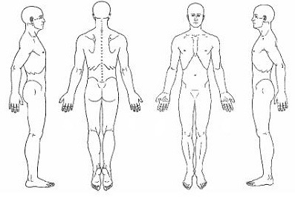
- What makes it worse?______________________________________________________________
________________________________________________________________________________
- What makes it better?______________________________________________________________
________________________________________________________________________________

PLEASE COMPLETE QUESTIONS ON THE BACK

- In general, would you say your overall health right now is…
__Excellent __Very good __Good __Fair __Poor
- Do you now have, or have you ever had, any of the following?
Diabetes Yes/No Prior Surgery Yes/No
High Blood Pressure Yes/No Are you Pregnant Yes/No
Pacemaker Yes/No Metal Implants Yes/No
Circulatory Disease Yes/No Cancer Yes/No
Kidney Problems Yes/No Osteoporosis Yes/No
Respiratory Problems Yes/No Grind Teeth Yes/No
Epilepsy Yes/No Dizziness Yes/No
Broken Bones Yes/No Recent Weight Loss Yes/No
Bowel/Bladder Issues Yes/No Chronic Pain Yes/No
Pins/Needles/Numbness Yes/No Frequent Stress Yes/No
Chronic Headaches Yes/No STD Yes/No
Hepatitis A, B, or C Yes/No MRSA Yes/No
Arthritis Yes/No MS Yes/No
Parkinson’s Yes/No Thyroid Yes/No
ALS/Lou Gehrig’s Yes/No Lupus Yes/No
Degenerative Joint Disease Yes/No
- List any surgeries and dates: _____________________________________________________________
____________________________________________________________________________________
____________________________________________________________________________________
- List any prescribed medications and what they are for: _______________________________________
____________________________________________________________________________________
____________________________________________________________________________________
- List any over the counter medication or vitamin supplements: __________________________________
____________________________________________________________________________________
- List any Allergies: ______________________________________________________________________
_____________________________________________________________________________________

